BIT/2024/73820
Week 8 documentation
This week focused on separating gesture and keyboard logic into reusable OOP classes for cleaner, more maintainable mobile interactions via adding:
- Eventlogger service that logs every user interaction with a timestamp. Providing a real-time debug trail and satisfies the logging events as shown below
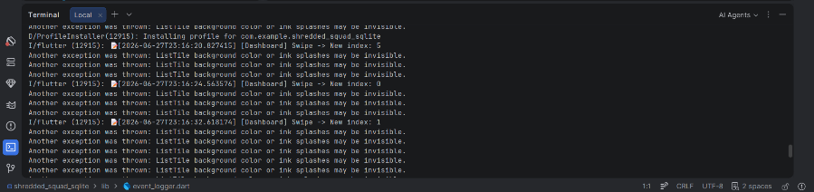
- Swipecontroller that manages tab navigation via horizontal swipe gestures by listening to left/right swipes on the between the main tabs indicated in indexes i.e the swiping of the screens from the dash board to index 4 which is the progress screen below
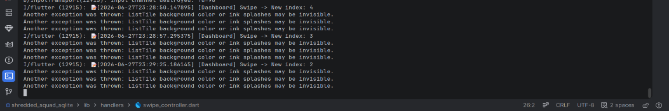

- KeyboardActionHandler that eases user login by allowing the pressing event via the key enter to login after credential input. The done key triggers user login.

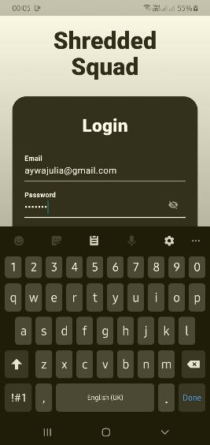
- LongPressHandler to display a context menu when a user long-presses a meal item on the Dashboard. The menu offers Delete Meal and View Details options, keeping the UI uncluttered while still providing powerful actions.
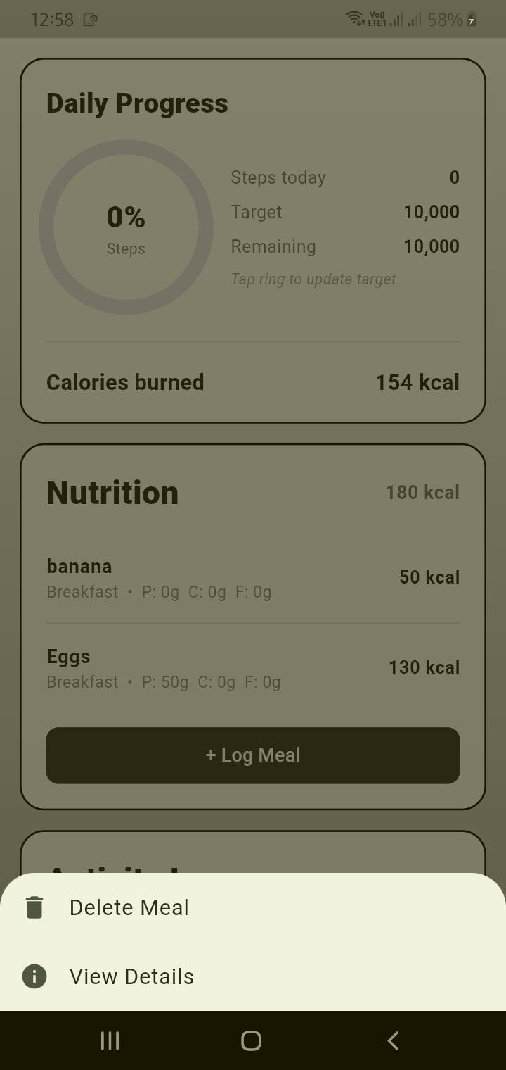

To apply the changes the main.dart (app connector) , and dashboard screen files were updated to implement the new advancements

